**Acknowledgement**

*I would like to write a word of sincere thanks to ‘****Dr.******Kalai Anand****’, our lecturer for the great guide and introducing us to new trends and technologies, also for sharing the knowledge and the precious time.*

*Hopefully, this time will result in a bright future for us, thanks to God for our great destiny.*

Table of Contents

1.1 Introduction 5

1.1.1 Company Background 5

1.1.2 Problem statement 5

1.1.3 Objectives 5

1.1.4 Major Functions 6

1.1.5 Deliverables 6

2.1 Project Plan 6

3.1 System Design 9

3.1.1 Cloud Design Pattern 9

4.1 Architectural Design 12

4.1.1 Use Case Diagram 12

4.1.2 Activity Diagram 13

4.1.3 Entity Relationship Diagram 17

4.1.4 Screenshots of Web App (UIA) 17

5.1 Implementations 25

5.1.1 Database Development and Deployment 25

5.1.2 Connecting Azure SQL to Web App 29

5.1.3 App Service Creation 30

5.1.4 Publishing Web App on Azure 31

6.1 Testing 32

6.1.1 Unit Testing 32

6.1.2 Performance Testing 36

Conclusion 38

References 39

Figure 1 Project Task sheet 7

Figure 2 Project Timeline 7

Figure 3 Task Track visual (a) 8

Figure 4 Task Track visual (b) 8

Figure 5 Group of Patterns - source (Cecaro, 2017) 10

Figure 6 Retry Pattern – source (Microsoft, 2017) 11

Figure 7 Use Case Diagram 12

Figure 8 Activity Diagram Overall functions 13

Figure 9 Activity Diagram Manage Profile Activity 14

Figure 10 Activity Diagram Booking a Flight 15

Figure 11 Activity Diagram View Bookings 16

Figure 12 Activity Diagram Online Check-in 16

Figure 13 ER Diagram 17

Figure 14 Home page (a) 18

Figure 15 Home page (b) 18

Figure 16 About page (a) 19

Figure 17 Tours and events 19

Figure 18 Contact page 20

Figure 19 Login Page 20

Figure 20 Sign Up Page 21

Figure 21 Profile Management Page 21

Figure 22 Dashboard after Login 22

Figure 23 View Bookings Page 22

Figure 24 Online Check-in Page 23

Figure 25 Flight Schedule Page 23

Figure 26 Passenger Details and Seat Selection Page 24

Figure 27 Confirmation Page 24

Figure 28 Database Configurations 26

Figure 29 SQL Database Creation on Azure 26

Figure 30 SQL Firewall Settings 27

Figure 31 Login into Azure Database from SQL Server 28

Figure 32 Azure database 28

Figure 33 Data Migration Tool 29

Figure 34 Connection String for Connection to Azure Database 29

Figure 35 App Service 30

Figure 36 Pricing tier S1 Standard 30

Figure 37 App Service Creation 31

Figure 38 Deploy (Web App) on Cloud 31

Figure 39 Performance Test Details 36

Figure 40 Performance Test Result 37

Table 1 Unit test for Login 32

Table 2 Unit Test for Sign Up 33

Table 3 Unit Test for Dashboard 33

Table 4 Unit Test for Online Check-In 33

Table 5 Unit Test for View Bookings 33

Table 6 Unit Test for Profile Management 34

Table 7 Unit Test for Booking a flight 34

Table 8 Unit Test for Passenger Details 35

Table 9 Unit Test for Confirmation Page 35

# 1.1 Introduction

## 1.1.1 Company Background

Ukraine International Airline (UIA) is the largest network of flights in Ukraine. Thus, it operates the flights domestic and internationally around the globe therefore it possesses a huge number of customers and clients that are committed at any time. On the other side, Ukraine International Airline (UIA) also provides the cargo services domestic and in different continents i.e. Europe, the Middle East, the United States, and Asia.

Currently, UIA serves their customers around the globe but they eagerly looking forward to expanding their services and adopt new technologies and new market trends in this era of technology. Hence, turning to a new distinct or enhancing the business is never an easy task, it always resulted in challenging tasks. Hence, UIA also possesses some problem over current scenarios that is discussed in the section below.

## 1.1.2 Problem statement

As it is mentioned in the introduction of Ukraine International Airline (UIA), that the company is looking forward to adopting new market trends, since there are some issues noticed in the current system that prevents the customers beyond Ukraine to perform their actions over a website. Denial of service (DOS) attacks were at major notice that cause the website performance to slow down and hurt the site’s reliability as well.

UIA has been utilizing the technology over a long-time interval to benefit in cost reduction, innovation, and to improve the customer service, it has been through a huge paperless and package of sophisticated software for analysis tasks. Now UIA has decided to eliminate the current problems and innovate the online system with a breakthrough innovation to make its way out of its challenges.

## 1.1.3 Objectives

UIA has studied both the Amazon and Azure Web Services, whereas the company has chosen to utilize the facilities provided by the Microsoft Azure web services as it is very compatible with open source software. UIA aims to utilizes the cloud features to overcome the issues that currently arises. To facilitate the customers through a best unstoppable and uninterruptable service of cloud.

## 1.1.4 Major Functions

The major functions of the web application include as below.

1. Flight Booking Process.
2. Management of Booking.
3. Viewing of Bookings.
4. Customer sign up and sign in.
5. Profile Management of customer.

## 1.1.5 Deliverables

The deliverables contain a package of the entire system that includes the elements below:

1. Design and Develop web app on Azure.
2. SQL database or storage on Azure.
3. Quality website with concise and meaningful content.
4. Appropriate navigations.
5. Web application performance test.
6. Scaling.
7. Source code.
8. A fully functional web application.

# 2.1 Project Plan

The section of the report discusses about the project planning that was a pre-phase of the development. Project planning divides into two main categories i.e. the system development and the documentation (the user manual), hence it will allow the reader to know more about the development cycle of the UIA cloud based application that carries a bunch of development process.

As the developer has classified the project into few different segments within the development phase as well, that helps the team to works smoothly and faster, so the application launched on the given time. On the other side, the documentation has also been considered important so let understand the reader or developer about this system so that the future enhancements can be made at ease. Hence, the development phase, as it will be illustrated in the figure below, explains that the development was been tested at all time and if any issues which was then eliminated and refine to smoothly run the system. To know more the project, the figure below illustrates more in details.

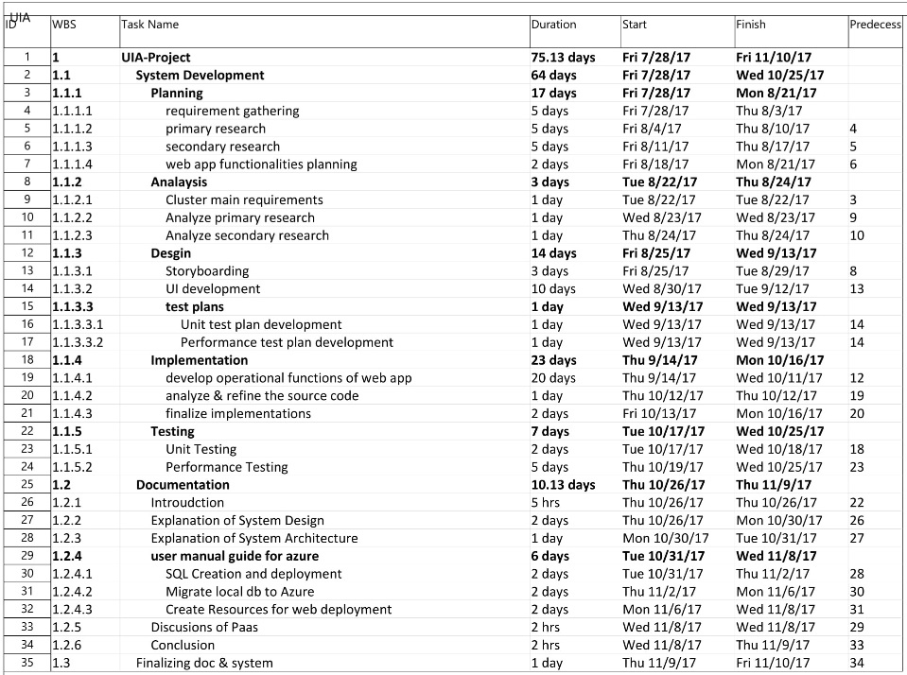

Figure 1 Project Task sheet

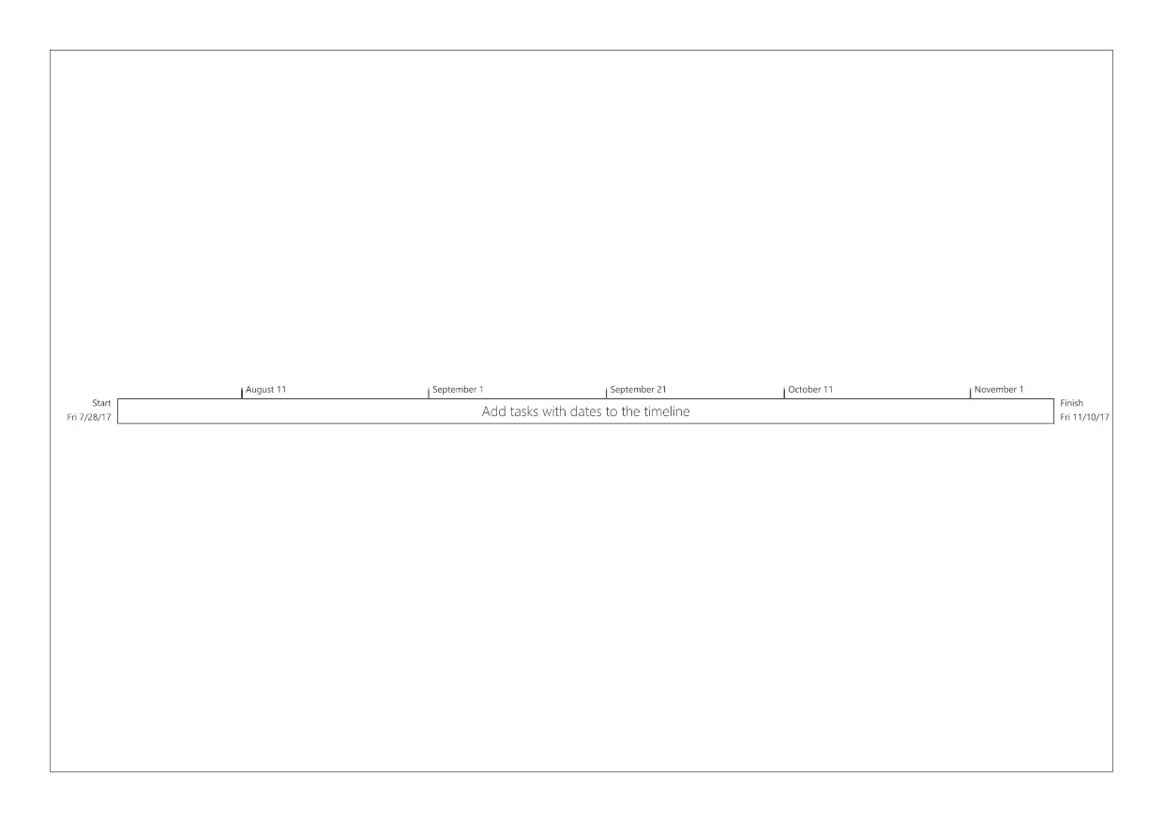

Figure 2 Project Timeline

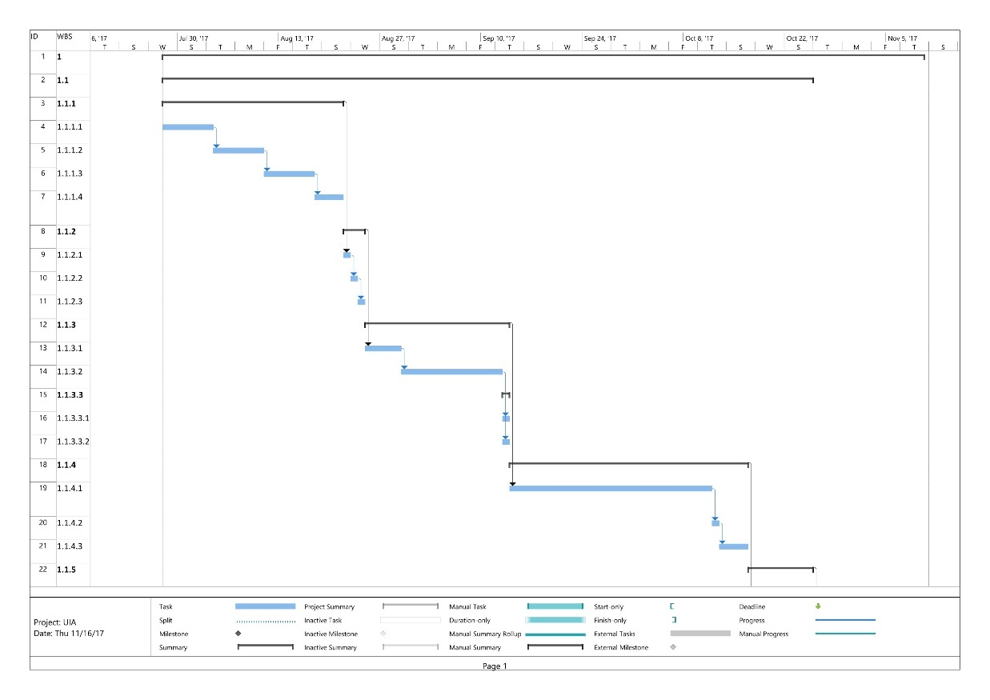

Figure 3 Task Track visual (a)

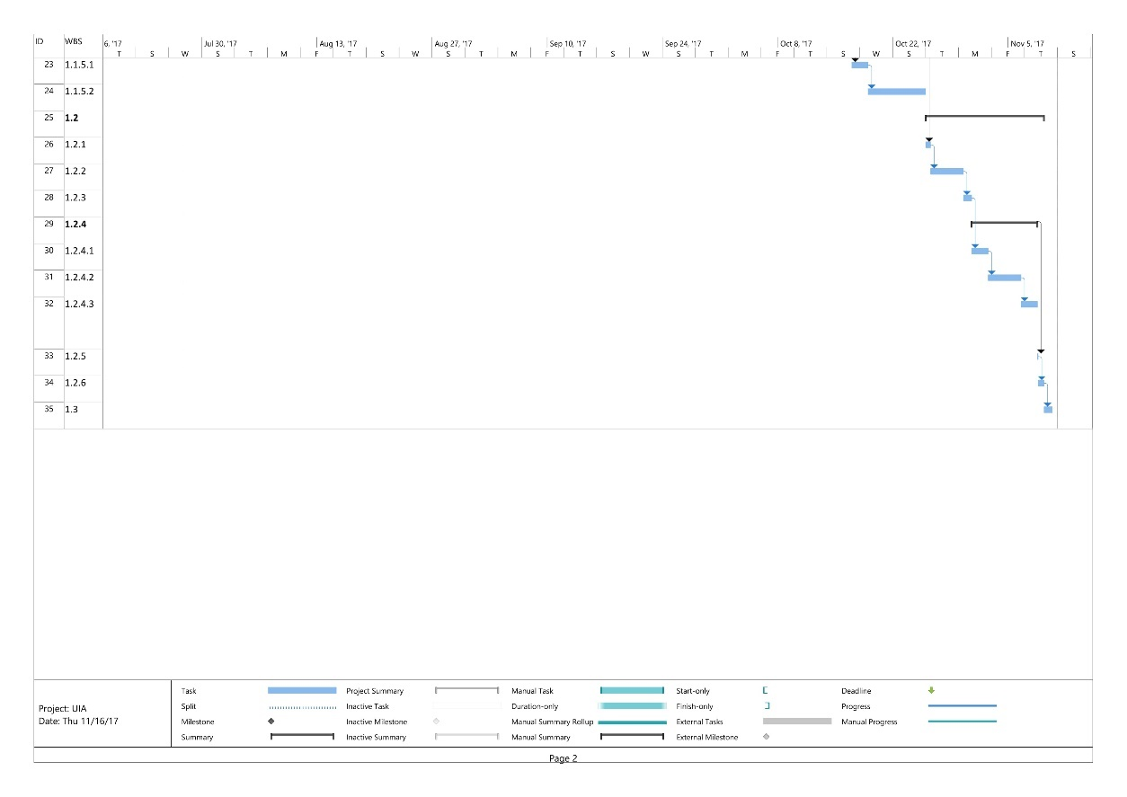

Figure 4 Task Track visual (b)

# 3.1 System Design

This section is related to discussions of the system design concepts that can be considered as a requirement for the different system, in this case the web application that suffers from different issues can also utilize the design concepts such logical models, design pattern and many other elements that are relative. Hence, for the cloud computing there are some pre-defined models that helps to eliminate the common problem by using the as a design pattern.

## 3.1.1 Cloud Design Pattern

Developing a cloud based application consists of unique characteristics. Cloud applications runs on commodity of hardware, software, provided different services such as monitoring, managing and dealing the unpredictable workload and user loads. Such factor usually results in a wide a range of some common problems that occurs to low-down the performance, reliability or many different considerations that requires to be solved so that the application is resilient and strong enough to go online and recover the failures in the system. (Homer, 2014)

To prevent from the failure and recover those problem, confliction arises in the cloud applications, the cloud (considering Microsoft Azure) provides a package (bunch) of different design patterns that are pre-implemented and can be reused in the applications throughout to solve the issues. Specifically, in Microsoft Azure each patter carries its design considerations and provide an ease by guiding the way to implement the features consisted in the patterns. There are vast variety of pattern which are than grouped into different numbers and appropriate sections such as **‘*Design and implementations*’**, **‘*data management*’**, **‘*performance and scaling*’** etc. Hence, these patterns can be used in the development of system or in eliminating the problems if occurs. Each of these patterns explains the way of implementations in cloud through a simple guide of key considerations. The key benefits of implementing the pattern from cloud is to make the development process more efficient, improve the quality and service of the application. (Homer, 2014)

As it is mentioned in the discussion above that the vast variety of patterns are grouped in few number of segment, it is illustrated in the figure below.

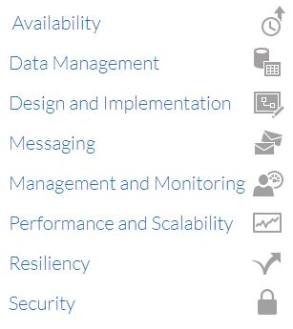

Figure 5 Group of Patterns - source (Cecaro, 2017)

To have more clear understanding on the patterns, the developer is elaborating one of the patterns in this document that can be also be considered in the development of the UIA system.

**• Retry Pattern**

This pattern helps to recover the problem of transient failure, in simple words, it enables an application to manage the short-term (no long lasting) connection or network problem by retrying over a short time interval. (Microsoft, 2017)

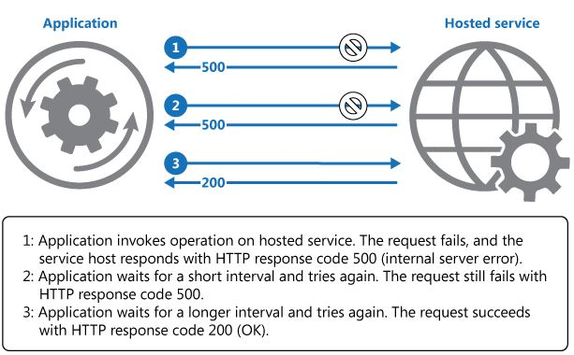

Figure 6 Retry Pattern – source (Microsoft, 2017)

In the above mentioned figure, it clarifies that the application requests a hosted service where it fails and return an error (500 – internal server error), consecutively it keeps trying over and over and each time it waits a bit longer than before, as you can view that the third repeated request by the retry pattern accomplishes the task and returns the requested element.

# 4.1 Architectural Design

Architecture plays an important role throughout the development and while the system at its service. Architecture is a backbone of any system, where if the backbone rises the issues the entire system goes through a problem segment. However, the architecture of the UIA web application has been considered most importantly at the prior stage and the development design an architecture in such a way so that the current problems minimizes or eliminates. Hence, the architecture in this system are modelled in an efficient way. This section will illustrate the visuals of the logical tasks (decisions) and the designs involved as it can even identify the possible issues that may rise in future, so it can be solved before implementations.

## 4.1.1 Use Case Diagram

It illustrates the visual of the logical planning that decides the user’s activities, the number of users involved and primarily also clears the division of primary and secondary user. To be specific, it described in a shape of figure, the operational functions that can be performed in the system and by relativeness of the user.

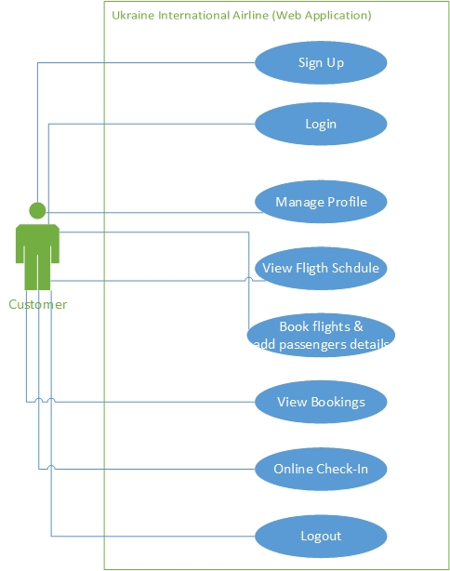

Figure 7 Use Case Diagram

## 4.1.2 Activity Diagram

This section illustrates the activities involved in the system, it visualizes the system consistency and explains that stepwise procedure of the system. The stepwise procedure can yield the satisfactory outcome if the order follows the correct sequence. This graphical illustration visualizes the sequence flow of different activities in the system as below.

* Overall activities

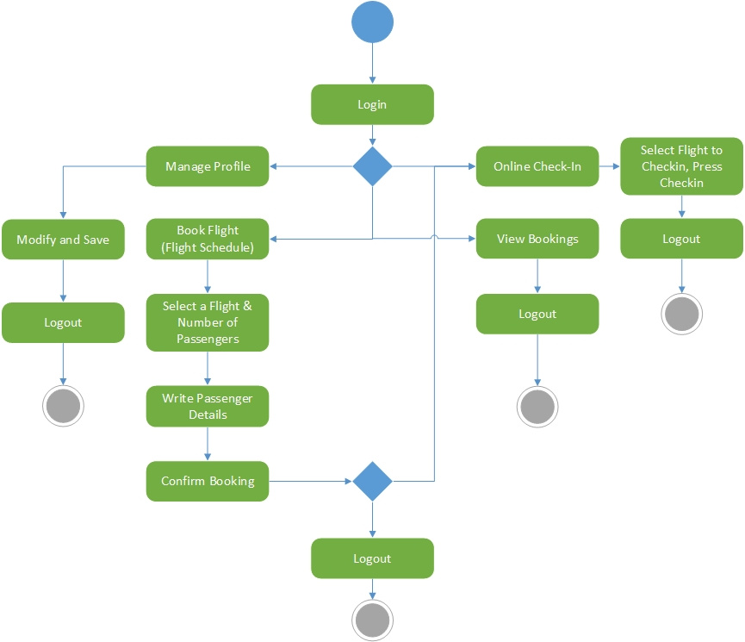

Figure 8 Activity Diagram Overall functions

Since the system focuses on single tenant, the customer (user) is considered as a primary user that can perform activities in a sequence illustrated in the figure above to yield the expected outcome.

* Manage Profile

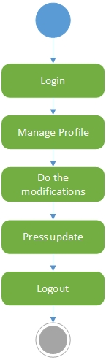

Figure 9 Activity Diagram Manage Profile Activity

* Flight Booking

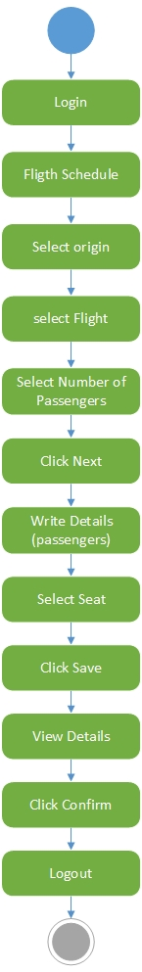

Figure 10 Activity Diagram Booking a Flight

* View Bookings

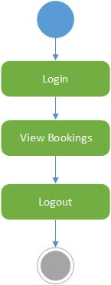

Figure 11 Activity Diagram View Bookings

* Online Check-in

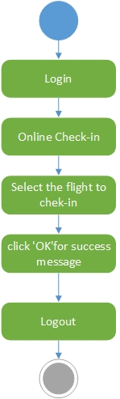

Figure 12 Activity Diagram Online Check-in

## 4.1.3 Entity Relationship Diagram

Entity relationship diagram illustrates the associations between the relational schemas or entities. According to the system requirement considerations, an ERD has been developed to perform better operations as below.

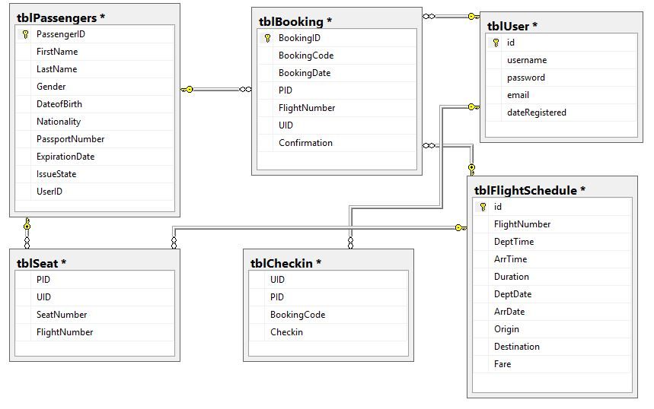

Figure 13 ER Diagram

## 4.1.4 Screenshots of Web App (UIA)

This section illustrates the sight of the user interface (front-end view), as one of the requirement was to create a good design with better quality contents so the site looks appropriately proficient. Hence the developer has developed a responsive website with a great hands-on effort on user interface as well.

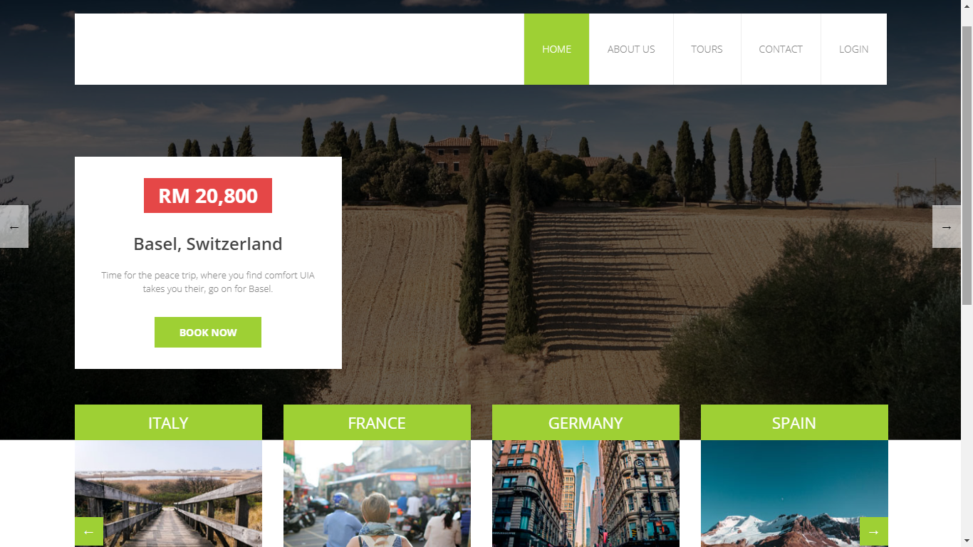

Figure 14 Home page (a)

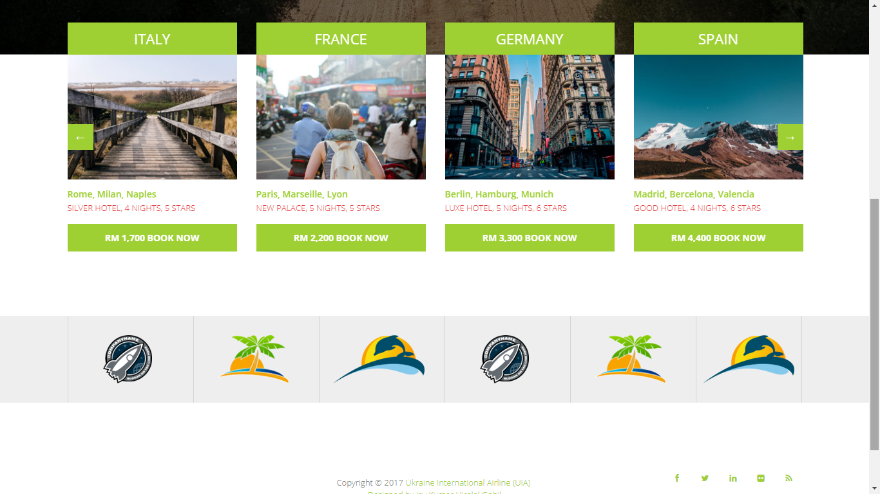

Figure 15 Home page (b)

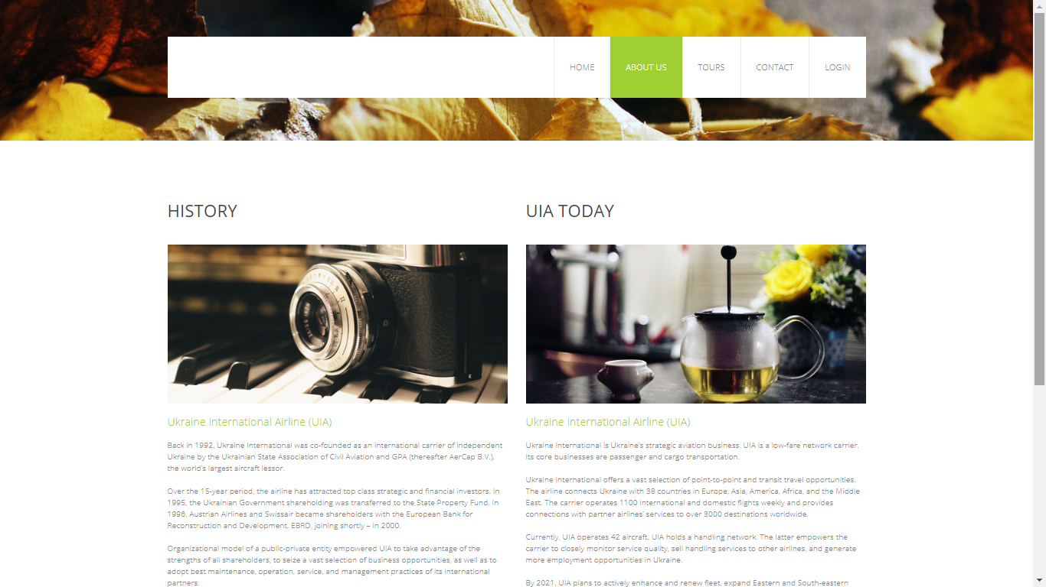

Figure 16 About page (a)



Figure 17 Tours and events

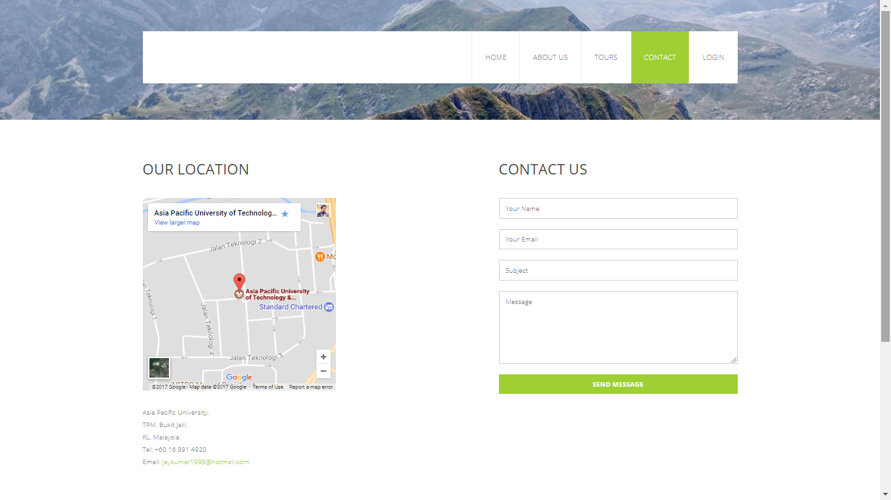

Figure 18 Contact page

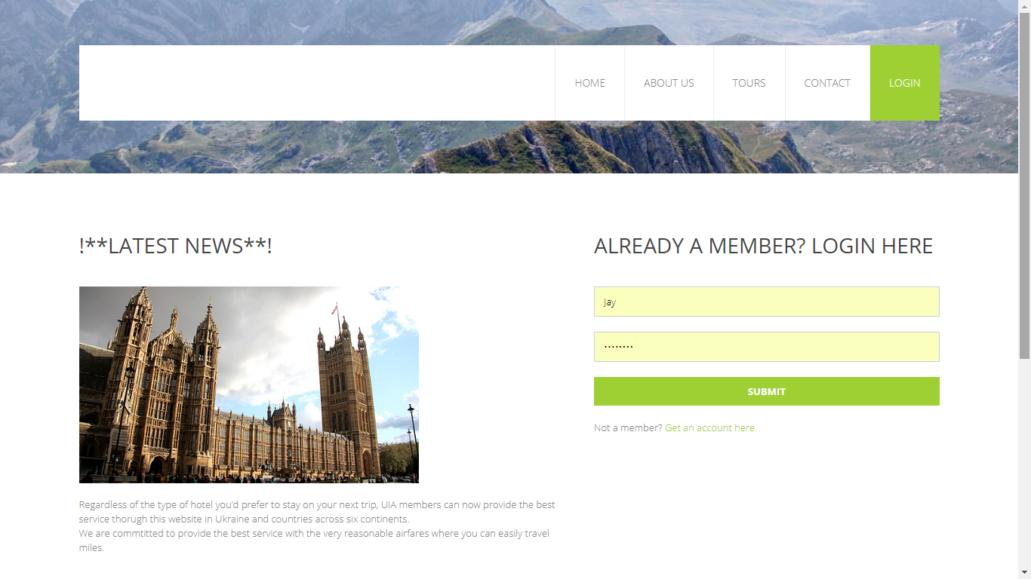

Figure 19 Login Page

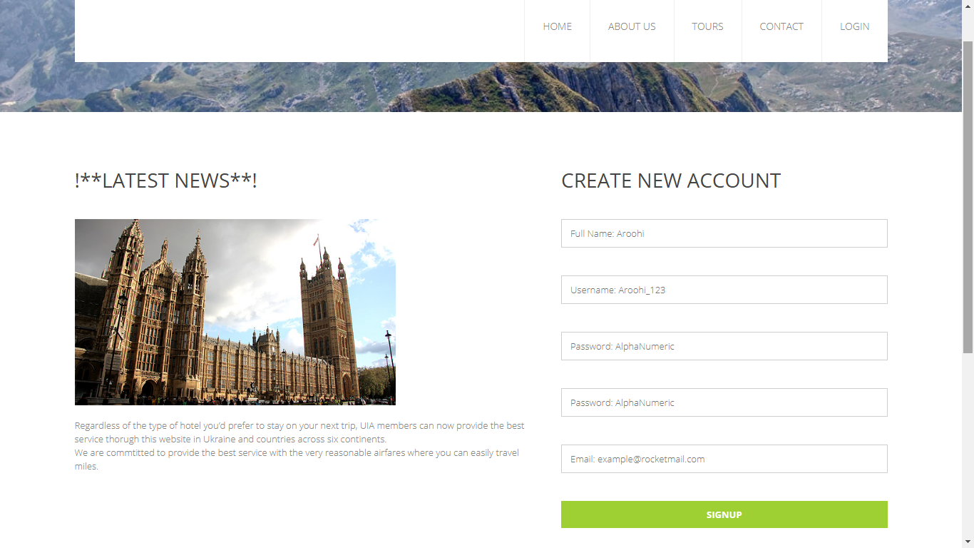

Figure 20 Sign Up Page

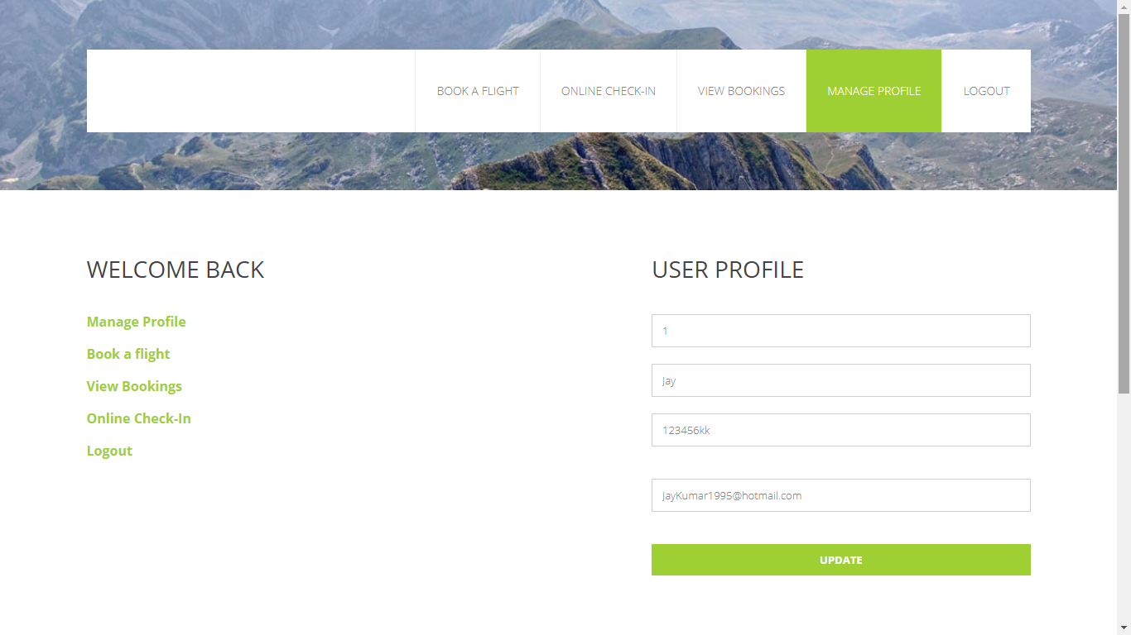

Figure 21 Profile Management Page

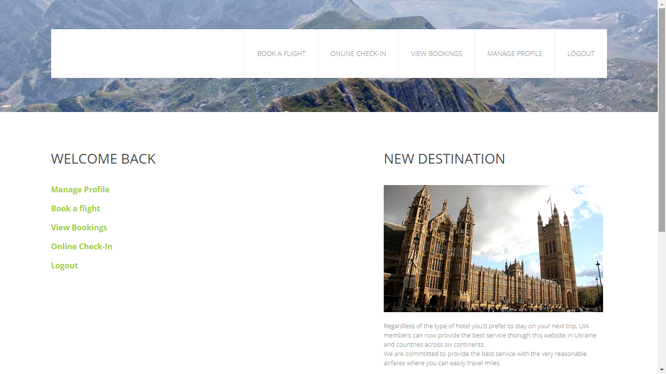

Figure 22 Dashboard after Login

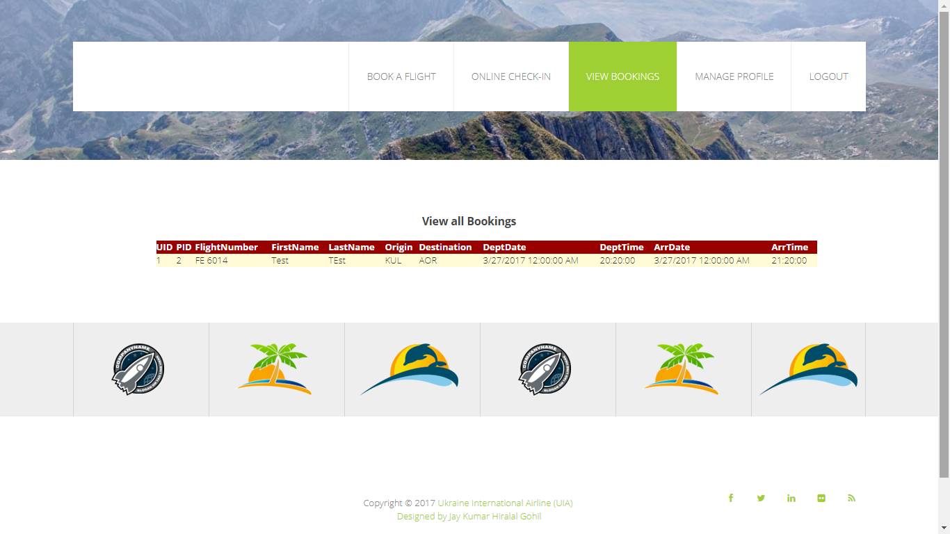

Figure 23 View Bookings Page

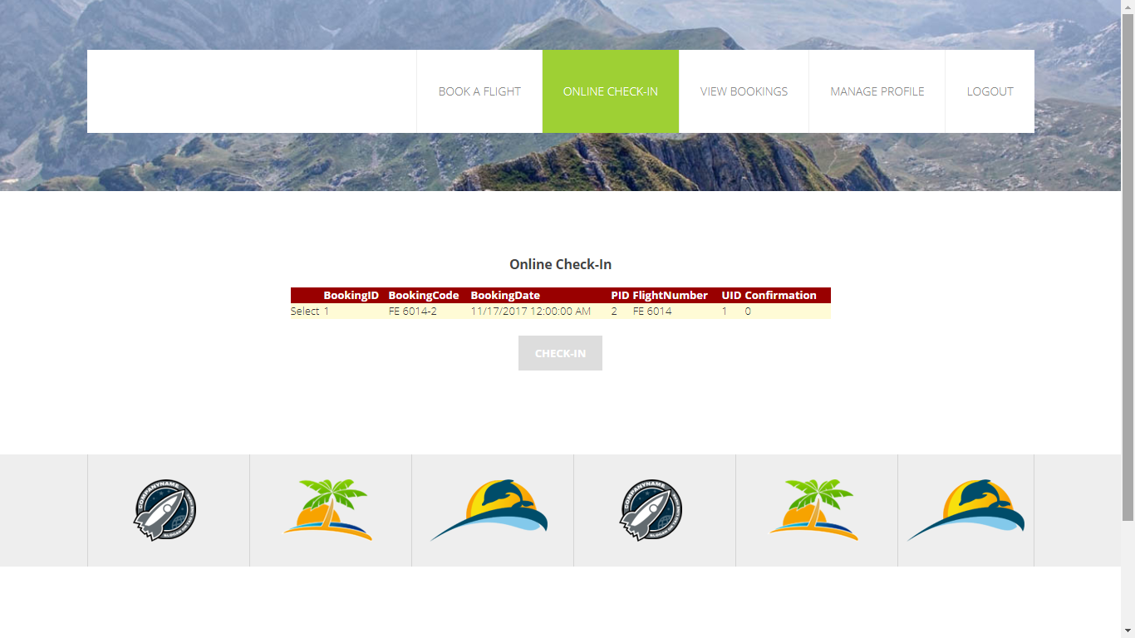

Figure 24 Online Check-in Page

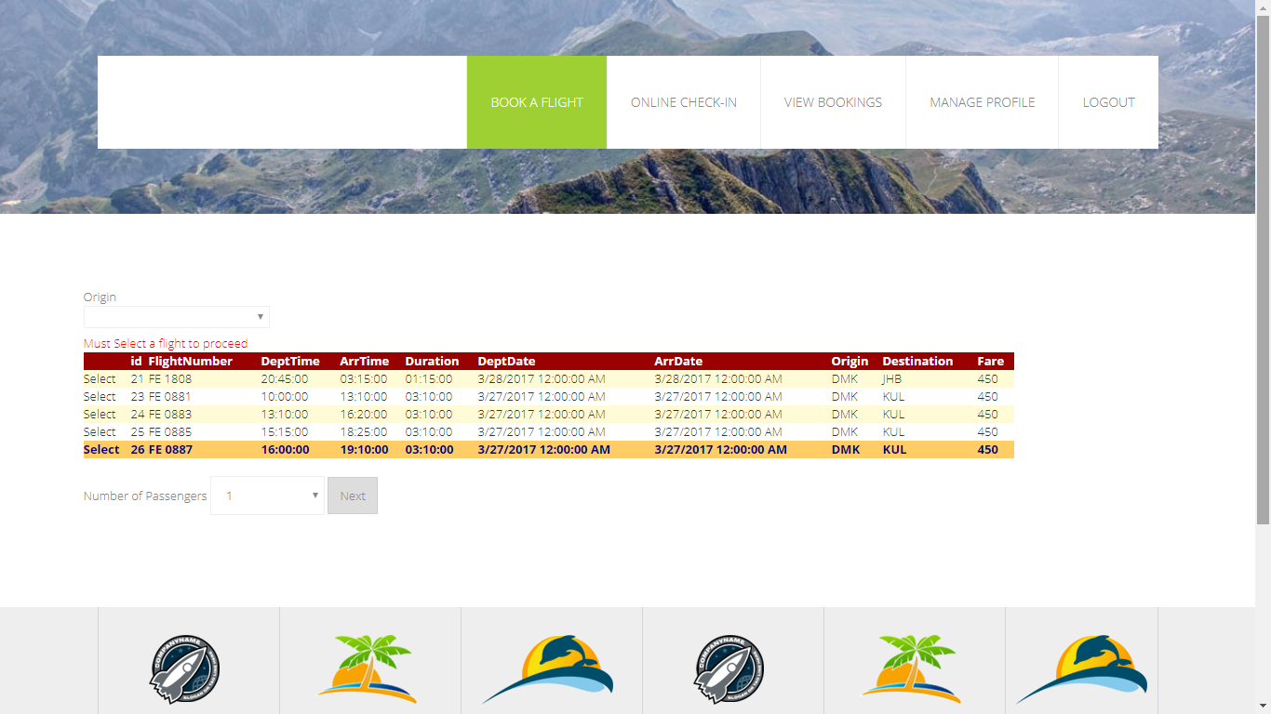

Figure 25 Flight Schedule Page

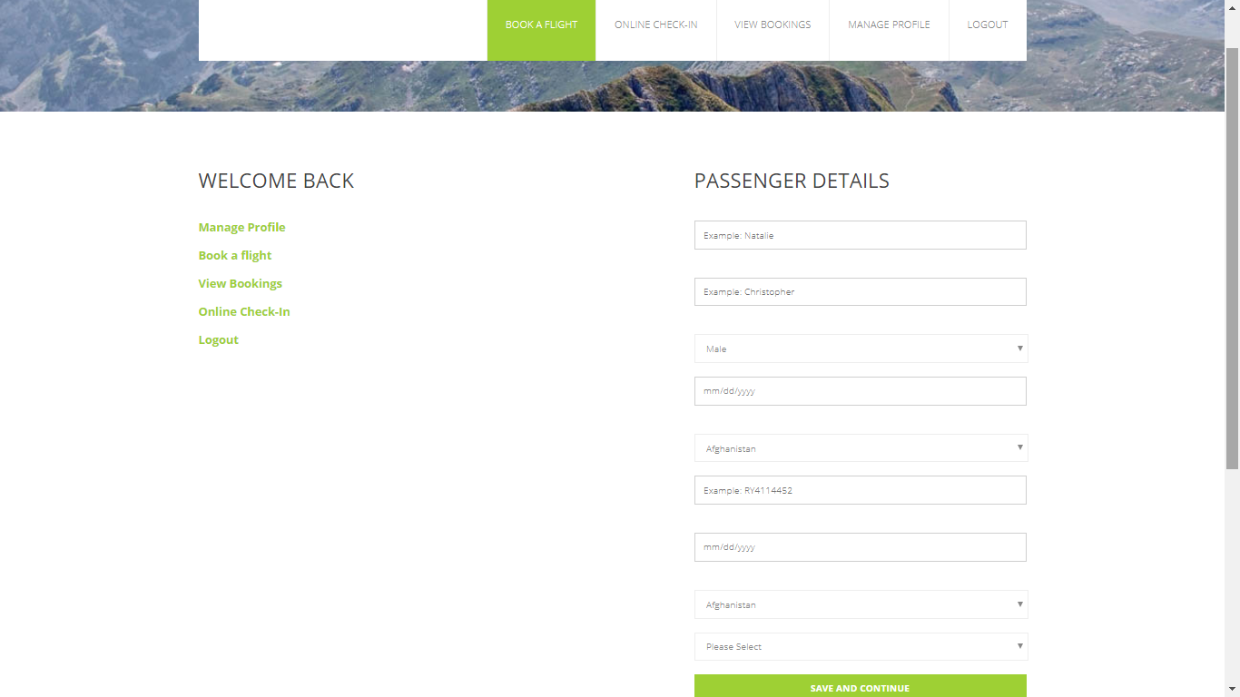

Figure 26 Passenger Details and Seat Selection Page

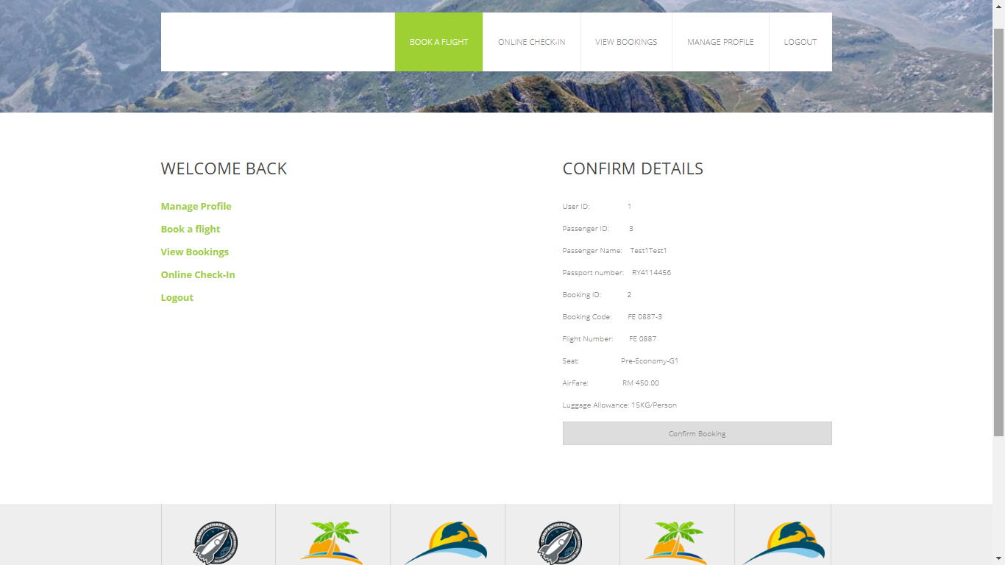

Figure 27 Confirmation Page

# 5.1 Implementations

This section will discuss about the critical development phases and the approach for the implementation of the system. Specifically, UIA has been developed using ASP.NET (web application project), using .Net Framework and whereas for dynamic user interface the Bootstrap features are also been utilized. Along the way, for the back-end development, the SQL Database (on Azure) is preferred for storing valuable data. Hence there were some steps in the development which will be discussed below.

## 5.1.1 Database Development and Deployment

The database development process is in Microsoft SQL Server Management Studio (2014) & Microsoft Azure, hence the steps that were involved are as below.

1. Firstly, the developer designed an ERD with appropriate entities and attributes.
2. Then ERD was implemented in a shape of database (locally on workstation – on premises database).
3. The data was populated once the implementation was done.
4. Now the database was locally created, hence It was now ready to migrate on Microsoft Azure.

The above steps explained the local creation of database, now along the way, developer explored some new tools where one of the tool named as ‘***Microsoft Data Migration Assistant***’. This tool assisted to migrate the existing data (local database data) on cloud database. Hence, the steps were involved are as below.

1. Now, the developer created the database on Azure and named as **‘DDAC’**, the server was in **‘South East Asia’** to have a better performance. The pricing tier was selected as **S1 (standard)**, the server was set as ‘**uia123**’ and the resource group was created as ‘**myResourceGroup**’.

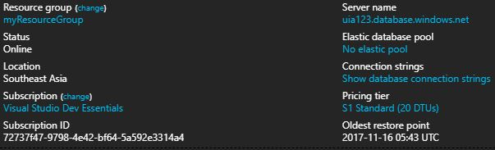

Figure 28 Database Configurations

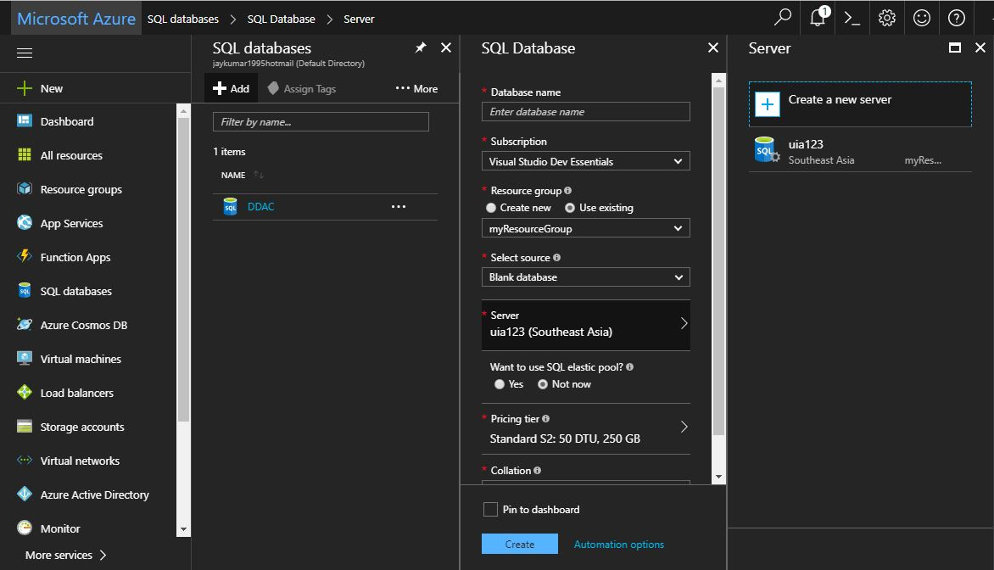

Figure 29 SQL Database Creation on Azure

Once you reach the point as shown above, for the SQL server creation click ‘**Create New Server**’ and write the fields, as it is shown in the figure above that the server is created as ‘**uia123**’.

1. Once the SQL database has been created then do the set firewall setting by selecting the database **(Database > Overview > Set server Firewall > Add Client IP > Save)**.

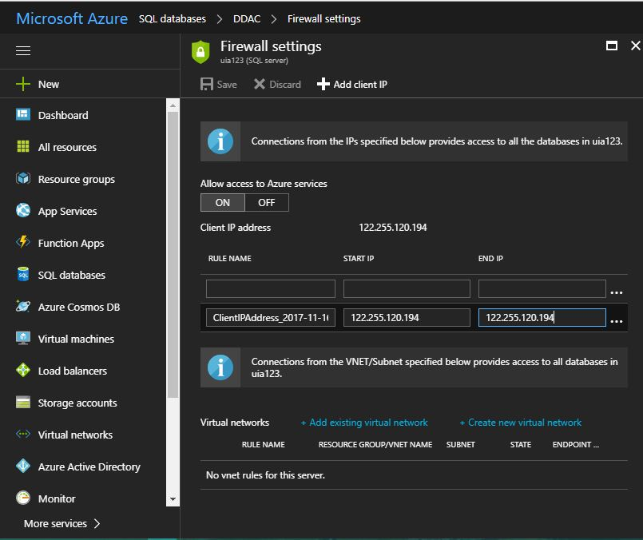

Figure 30 SQL Firewall Settings

1. Create the entities in database on Azure, go to the SQL Server Management Studio, login for local databases and then expand your database and tables, right click on the table (for example: tblUser) generate its ‘**Create Table**’ script(s) and save it on a notepad file, do same for all the tables.
2. From the SQL Server Management Studio, logon to you newly created SQL Server on Azure as below.

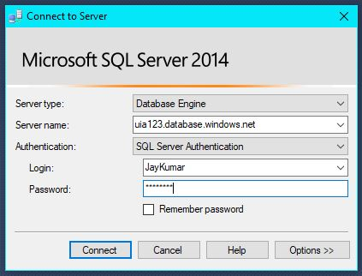

Figure 31 Login into Azure Database from SQL Server

1. Once you are logged in into the system, it will display all the databases created on Azure as below.

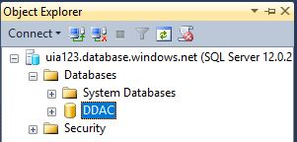

Figure 32 Azure database

1. Now the tables can be created using the scripts that were copied before in the notepad file.
2. For migrating the data, as mentioned above the developer has explored and utilized the new tool called ‘***Microsoft Data Migration Assistant***’.

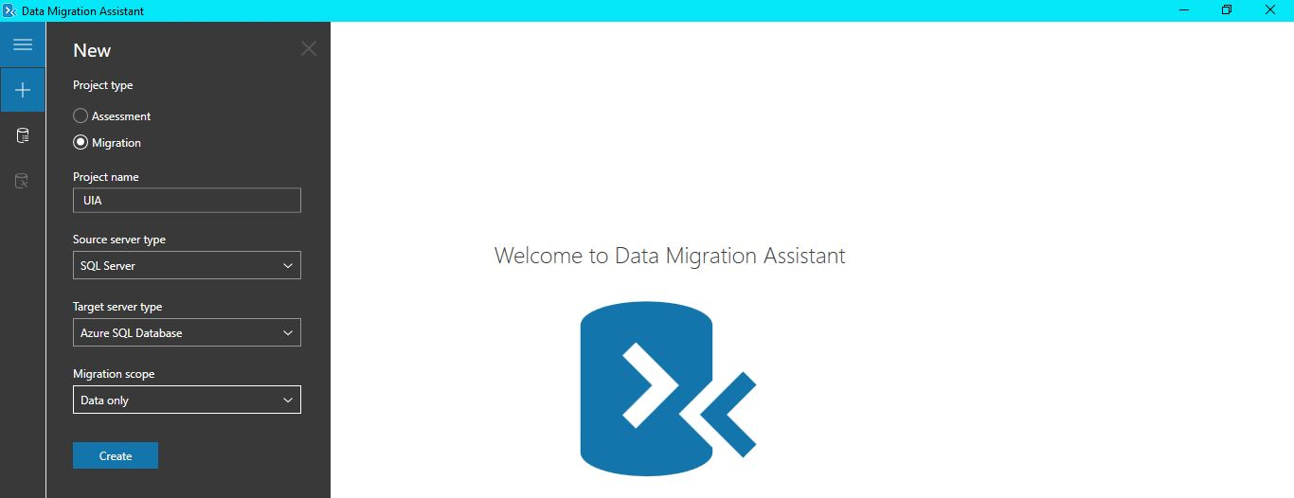

Figure 33 Data Migration Tool

1. Once the data is successfully migrated, we have database on Azure with the data populated within it. Hence the developer will now explain to connect database to the application and publish (deploy) it.

## 5.1.2 Connecting Azure SQL to Web App

Connecting the database on Azure (existing database ‘DDAC’), where the developer first developed a website locally on the local machine and connects to the database on Azure. The connection was possible through a connection string provided by the Azure database as below.

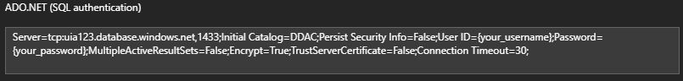

Figure 34 Connection String for Connection to Azure Database

Note: In the connection string above credentials are as follow, ‘**User ID = web_user and Password = Abcdonetwo3’**.

This connection string is initially used in web development where the database related functions are needed. After doing this the application (locally) working along the database (on Azure as DDAC) functions. Now the deployment process is in the other section.

## 5.1.3 App Service Creation

To publish (deploy) the web application, the Azure requires to create an App Service that assigns the storage, location etc. The App service is created as below.



Figure 35 App Service

The figure shows the App service and its plan, where scaling was based on the standard package as it gives a suitable bunch of storage, instances etc. The pricing tier S1 was used as figured below.

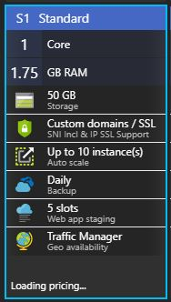

Figure 36 Pricing tier S1 Standard

The steps to create an App service are as below.

1. Click App Service on Azure portal.
2. Click Add button.
3. Select Web App in the list.
4. Click Create.
5. Write the App Service name, select resource group (if existing) or create new
6. Click on App Service plan, create an appropriate service.
7. Then click create (Web App) as shown below.

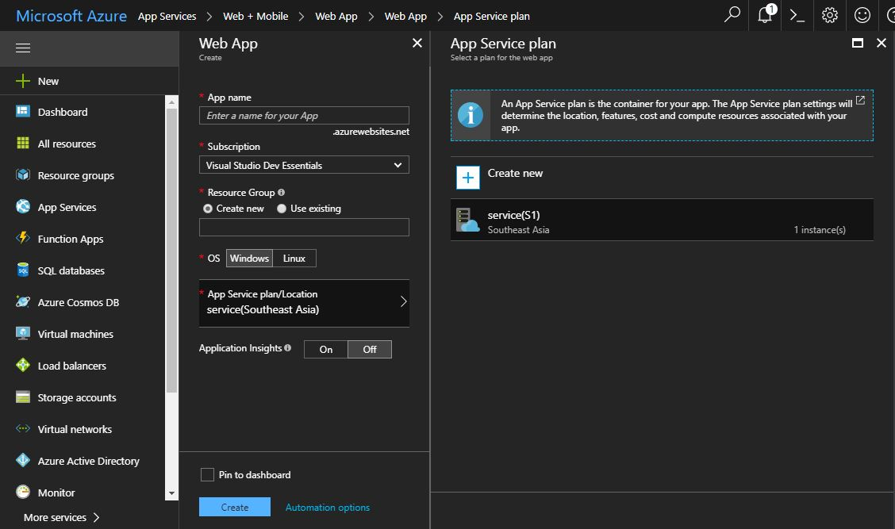

Figure 37 App Service Creation

## 5.1.4 Publishing Web App on Azure

After the App Service has been created, go the web application on the local machine, right click on the solution and click publish. When the publish tabs open, select existing from there and select the App service that is recently created on Azure and click publish. It takes few minutes to deploy the web application on the cloud.

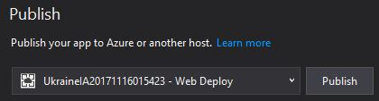

Figure 38 Deploy (Web App) on Cloud

Once the process is done, it will automatically navigate you to the default (first page) of the web application on the browser. Hence, now the web application is deployed on the cloud as well as the database in on Azure. The web application is ready to use.

Note: The default URL for the web application is ‘**http://ukraineia20171116015423.azurewebsites.net/index**’

# 6.1 Testing

Testing is an important phase in the development process. It helps to mitigate the risk of unexpected outcome throughout the development and while the application is under service. Hence, the developer has segmented the testing under two different tests as Unit Test and Performance Test. Unit test will help to analyze each single unit of the application with the actual output, if checks whether it yields an expected outcome. On the other side, Performance testing is helps to analyze a web application performance, it helps to check whether the application can handle a heavy concurrent traffic and the workload.

## 6.1.1 Unit Testing

To complete the testing phase, as the developer mentioned above that the testing is also done as unit test where each single unit is being tested in the website. Hence the test below was successful and to view the unit along with its result, the developer has mentioned all the unit test below.

* Login

|  |  |  |  |  |  |  |
| --- | --- | --- | --- | --- | --- | --- |
| **Pages** | **Test Case** | **Test Type** | **Test Steps** | **Expected Result** | **Actual Result** | **Success** |
| Login | Username required | Unit testing | Leave it empty | Error message | Record doesn’t exist. | Yes |
| Password required | Leave it empty | Error message | Record doesn’t exist. | Yes |
| Wrong username, right password | Write invalid credentials | Error message | Record doesn’t exist. | Yes |
| Wrong password, right username | Write invalid credentials | Error message | Record doesn’t exist. | Yes |
| Correct username and password | Write valid credentials | Should navigate to dashboard | Dashboard appears | Yes |

Table 1 Unit test for Login

* Sign Up

|  |  |  |  |  |  |  |
| --- | --- | --- | --- | --- | --- | --- |
| **Pages** | **Test Case** | **Test Type** | **Test Steps** | **Expected Result** | **Actual Result** | **Success** |
| Sign-Up | All fields required | Unit testing | Leave all fields empty | Required field symbol “*” | Display this symbol “*” | Yes |
| Different text in Password and Confirm Password | Write different text in both password fields | Password doesn’t match symbol “*” | Display this symbol “*” | Yes |
| Write valid inputs | Write valid inputs | Success messages | Profile Created | Yes |

Table 2 Unit Test for Sign Up

* Dashboard

|  |  |  |  |  |  |  |
| --- | --- | --- | --- | --- | --- | --- |
| **Pages** | **Test Case** | **Test Type** | **Test Steps** | **Expected Result** | **Actual Result** | **Success** |
| Dashboard | Navigation Bar | Unit testing | Click each menu item | Should go to appropriate page | Go to appropriate page | Yes |

Table 3 Unit Test for Dashboard

* Online Check-in

|  |  |  |  |  |  |  |
| --- | --- | --- | --- | --- | --- | --- |
| **Pages** | **Test Case** | **Test Type** | **Test Steps** | **Expected Result** | **Actual Result** | **Success** |
| Check-In | Check-in without flight | Unit testing | Don’t select flight and press check-in | Error message | No flights selected | Yes |
| Check-in selected flight | Select flight and press check-in | Success message | Check-in done | yes |

Table 4 Unit Test for Online Check-In

* View Bookings

|  |  |  |  |  |  |  |
| --- | --- | --- | --- | --- | --- | --- |
| **Pages** | **Test Case** | **Test Type** | **Test Steps** | **Expected Result** | **Actual Result** | **Success** |
| View Booking | View all bookings based on user logged in | Unit testing | Click view bookings in navigation bar | Should display all bookings of current user | Displays current user bookings | Yes |

Table 5 Unit Test for View Bookings

* Manage Profile

|  |  |  |  |  |  |  |
| --- | --- | --- | --- | --- | --- | --- |
| **Pages** | **Test Case** | **Test Type** | **Test Steps** | **Expected Result** | **Actual Result** | **Success** |
| Manage Profile | Data already in fields | Unit testing | Click manage profile | Current user profile data should be already in fields | Data appears in fields | Yes |
| Required fields | Remove data from enabled fields and update | Required field symbol “*” | Display this symbol “*” | Yes |
| Valid inputs | Write valid data and update | Should update | Profile updated | Yes |

Table 6 Unit Test for Profile Management

* Flight Booking

|  |  |  |  |  |  |  |
| --- | --- | --- | --- | --- | --- | --- |
| **Pages** | **Test Case** | **Test Type** | **Test Steps** | **Expected Result** | **Actual Result** | **Success** |
| Flight Schedule | Don’t select a flight and number of passengers | Unit testing | Don’t select a flight and number of passengers and click next | Error message | It shows error message | Yes |
| Select a flight and number of passengers | Select a flight and number of passengers and click next | Navigate to passenger details page | Go to passenger details page | Yes |

Table 7 Unit Test for Booking a flight

* Passenger Details

|  |  |  |  |  |  |  |
| --- | --- | --- | --- | --- | --- | --- |
| **Pages** | **Test Case** | **Test Type** | **Test Steps** | **Expected Result** | **Actual Result** | **Success** |
| Passenger Details | Required field | Unit testing | Empty fields, no seat selection click next | Required field symbol “*” | Display this symbol “*” | Yes |
| Required seat selection | Write in fields, don’t select a seat | Error message | It shows error message | Yes |
| Valid input | Select seat, write passenger details and next | Displays given details for confirmation | Shows given details for confirmation | Yes |

Table 8 Unit Test for Passenger Details

* Confirmation Page

|  |  |  |  |  |  |  |
| --- | --- | --- | --- | --- | --- | --- |
| **Pages** | **Test Case** | **Test Type** | **Test Steps** | **Expected Result** | **Actual Result** | **Success** |
| Passenger Details | Confirmation | Unit testing | Click confirm | Confirmation message appears | It displays a successful confirmation message | Yes |

Table 9 Unit Test for Confirmation Page

## 6.1.2 Performance Testing

Since the company has chosen Microsoft Azure as a deployment cloud, therefore one of the good feature that Azure provides is Performance testing, however it gives us the traffic and time limit to test the performance within the given time interval. Hence, the performance test was performed, and the result was successful. The analysis is figured below.

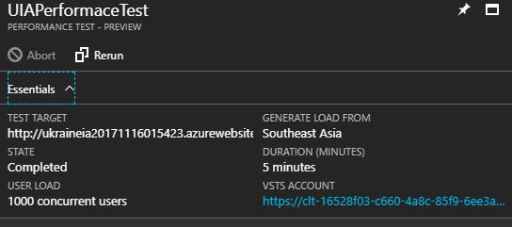

Figure 39 Performance Test Details

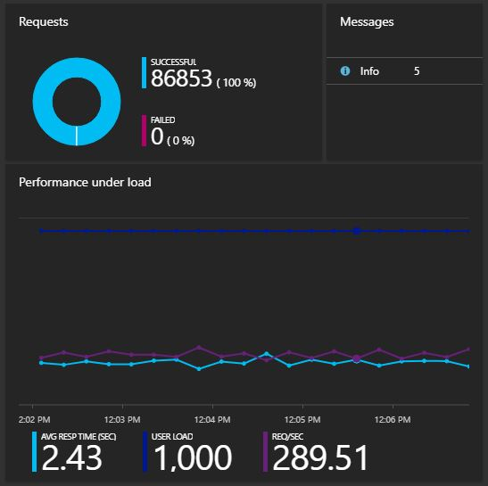

Figure 40 Performance Test Result

# Conclusion

Conclusively, the development has always been a challenging task in all aspects. Any project development goes through a huge number of critical path, bugs, success/unsuccess development, similarly the required system past through an exception and different of challenges. However, the online, offline resources as well as the given tutorials resulted in a positive way and an accomplishment. There were many new explorations by the developer hence some of them utilized. Microsoft Azure platform is now considered a good platform to work on cloud development, therefore the developer’s consideration now also relies on the Azure platform whereas in future it might help the developer for cloud project.

It is an experience counted for the developer as Microsoft Azure was a new environment to the hands-on. It can considerably be the later development platform for the developer, hence the technologies used in Azure are great as it made the project accomplishment successful, variety of different tools even guided along the development process.

I would like to write a sincere thanks to **Dr. Kalai Anand** for being as a guide at all time, it was a pleasure working, the entire journey of this cloud computing application designing, and development introduced a variety of new trends and technologies and with the helpful materials provided by the Dr. Kalai Anand, the project meets it success.

# References

Cecaro, F. (2017). Azure Cloud Design Patterns - Cloud Academy Blog. [Online]. 2017. Cloud Academy Blog. Available from: https://cloudacademy.com/blog/azure-cloud-design-patterns/. [Accessed: 1 November 2017].

Homer, A. (2014). Cloud design patterns. [Place of publication not identified]: Microsoft.

Microsoft (2017). Retry. [Online]. 2017. Docs.microsoft.com. Available from: https://docs.microsoft.com/en-us/azure/architecture/patterns/retry. [Accessed: 1 November 2017].